**Exp.3 PUSH BUTTON SWITCH INTERFACE DOOR BELL CONTROL**

CIRCUIT DIAGRAM:

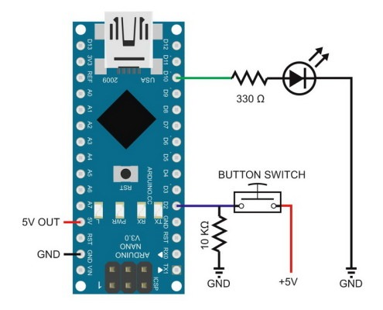

CONCEPT USED:

Push button is basically used to control two LEDS or to turn on/off two LEDS. When push button is pressed both LEDS glow and when push button is not pressed, LEDS remain turn off. Two resistors are connected in series with both LEDS as a current limiting resistor. Push button one side is connected with 5 volt source and other side is connected with ground through 10k ohm resistor. When push button is not pressed, logic low is used as input for pin 0 and when push button is pressed, logic high is used as an input of pin 0.

CODE:

void setup()

{

Serial.begin(9600);

Serial.print("Sketch: "); Serial.println(_FILE_);

Serial.print("Uploaded: "); Serial.println(_DATE_);

Serial.println(" ");

pinMode(pin_LED, OUTPUT);

digitalWrite(pin_LED,LOW);

pinMode(pin_switch, INPUT);

}

void loop()

{

if ( digitalRead(pin_switch) == HIGH)

{

digitalWrite(pin_LED, HIGH)

}

else

{

digitalWrite(pin_LED, LOW);

}

}

Learning and Observations:

In this experiment we learnt the following:

1. Basic circuit building with Arduino uno.

2. Interfacing a push button with Arduino uno.

Precaution:

1. The LED should not be connected in reversed direction because it doesn’t allow passing the current and circuit does not completed and LED will not glow.

2. The connections should be tight.

Learning Outcomes:

Via this activity we learn and acquire the skills about the following:

1. The application and usage of digital input/output pins of Arduino uno.

2. How push buttons work and their interfacing with Arduino Uno.

3. Understood the syntax to write the basic code in Arduino IDE.

4. How to Identify the P-N Junction of LED.